

Stop and Search Deep Dive
East Herts CSP

Introduction

Hertfordshire Constabulary’s Police Powers Board, chaired by a Chief Superintendent, has strategic oversight of the use of police powers, including the legitimate use of stop and search.

One of the actions of the Police Powers Board is to understand why we appear disproportionate, to hopefully allay concerns about discrimination, to resolve an explanation for disproportionality that reassures stakeholders about the integrity and validity of Stop & Search, to resolve what (if anything) should be done to address/re-balance disproportionality.

The National Police Chiefs Council (NPCC); College of Policing (CoP) and Her Majesty’s Inspectorate of Constabulary and Fire & Rescue Services (HMISFRS) have discussed these issues nationally and there is currently no central guidance for Forces on how to assess and understand disproportionality.

In Hertfordshire, disproportionality has been reviewed in several ways:
- Regularly discussed at the Police Powers Board and Office of the Police and Crime Commissioner’s (OPCC’s) Stop Search Scrutiny Panel
- Publication of a dissertation by Inspector 2745, entitled “Disproportionality in the practice of Stop and Search in Hertfordshire Constabulary, an exploratory study”

So how do we review and understand disproportionality?

One dictionary definition describes Disproportionality as,
“An extent that is too large or too small in comparison with something else”.
Another defines it as a group's representation in a particular category that exceeds expectations for that group.

Deep Dives are an open method of understanding disproportionality within a snapshot of time and data. Based on data from the Thinking & Analysis department, a Community Safety Partnership (CSP) deep dive criteria was agreed.

Thinking and Analysis prepared Stop and Search data from April to December 2021.
It was agreed to break this down into deep dive once a disproportionality peak had been identified from the raw data.

The disproportionality ratio is a measure of disparity between the rates of stop search on different ethnic cohorts. The ethnicity populations in Hertfordshire (2019 local authority estimated population data) have been used to determine the number of Stop Searches conducted per 1000 persons for each distinct ethnic group. These values have then been normalised, by dividing, against the rate observed for white individuals.

These 3 CSPs were highlighted as having the highest levels of disproportionately for black
males being stop searched and as such a deep dive was commissioned:

- St Albans
- Watford
- East Herts.

The deep dive was then discussed with the local CSP Chief Inspector, Detective Inspector and Safer Neighbourhood Inspector to add any local context to the data.

East Herts

East Herts contains the busy town of Hertford and the main other urban centres are Ware, Bishop’s Stortford and Sawbridgeworth.

From January 2021 to December 2021 540 Stop Searches were conducted within the CSP of East Herts.

When this was reviewed it showed the highest disproportionality ratio was in July 2021, indicating persons of a Black ethnic background appeared 26.2 times more likely to be stopped than those of a White ethnic background.

Although in July 21, East Herts, shows a high disproportionality rate, it might be worth noting that the volumes within that individual month are quite low. In this case, 5 stops on persons from a black ethnic background compared to stops on persons from a white ethnic background. It is therefore useful to look at the disproportionality over the year - total disproportionality figure for the 12-month period was 7.7 for those of a black ethnic background.

One of the reasons that East Herts figures can be so high, especially in an individual month, is due to the low population proportion:
0.7% of their population are Black (2019 estimates).

Data was then broken down to:
- April to September 2021 stop searches (6 months of data)
- Stop Searches conducted on Black Males (based on self-defined ethnicity).

This data was then further interrogated and given additional scrutiny as follows:
- Self-ethnicity breakdown
- Address of subject - Herts / Non-Herts / East Herts / Not stated
- Reason specified for the Stop and Search
- Stop and Searches linked to an operation
- Locations of Stop and Searches
- Subjects that were stop and searched more than twice and associated intel submissions
- Officers that stopped more than 2 black males in the period
- Outcomes
- Local context from East Herts Senior Management Team

Review of data, conclusions and recommendations

Self-ethnicity breakdown

17 stop and search incidents for black males from April to Sep 2021

Ethnicity - Self Defined - Black
Males
B1 - Caribbean | 2
B2 - African | 4
B9 - Black Other | 11
Grand Total | 17

Graph shows break down of black ethnicities
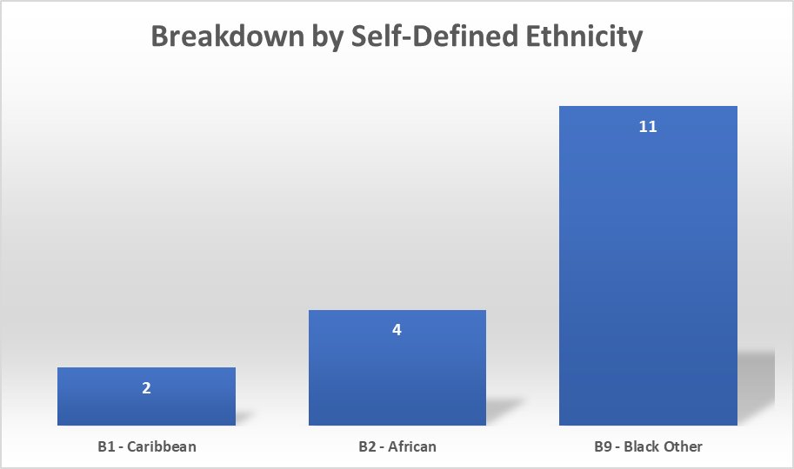

Address of subject - Herts/non-Herts/not stated

Table shows break down of residents
Address Details | No | %
Herts Residents | 6 | 35%
Non-Herts Residents | 4 | 24%
No Information Available | 7 | 41%

2 of the Herts residents above were from Bishops Stortford, within the East Herts area.

It should therefore be noted that 15 of the stops were of persons who either don’t live in East Herts or their addresses are unknown – therefore as the disproportionality ratio is measured against local resident population there are some obvious inaccuracies.

Reason stipulated for each stop and search

Table shows break down of search initiation reasons

Stop Search Reason
Intelligence led | 4 | 23.5%
Officer self-initiated | 7 | 41.2%
Incident related | 5 | 29.4%
Member of Public Led | 1 | 5.9%
Grand Total | 17 | 100%

Graph shows break down of search initiation reasons

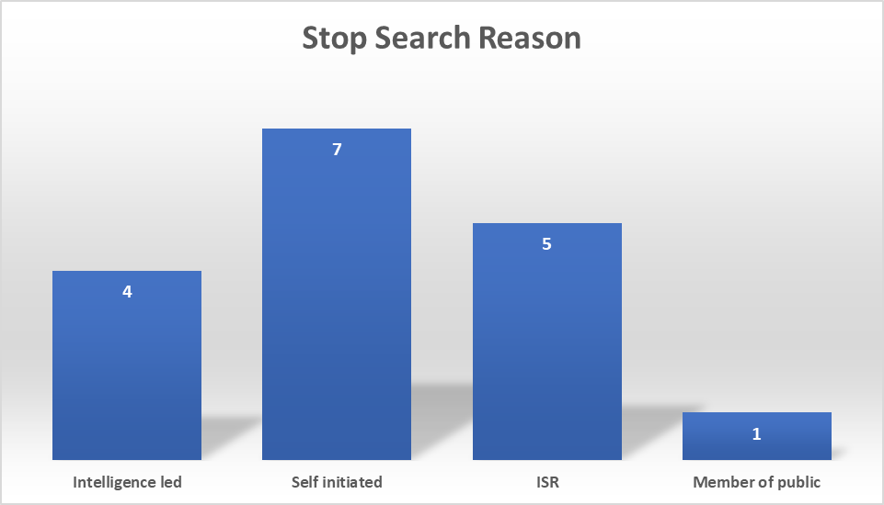

Out of the 17 searches conducted – 10 were carried out based on direction from intelligence, a member of the public or were attributed to an incident report held with the Force Communications Room following a call from a member of the public.

7 of the searches were spontaneous when the officer proactively initiated the encounter because of what they saw or heard at that time.

Stop and searches linked to an operation

There was just 1 operation identified within the grounds of the searches.

After a review by the CSP Detective Inspector, a further 6 searches within the sample are linked to operations demonstrated in below table:

Operation Name
Operation A | 2 | Drug dealing and robberies linked to night time economy disorder
Operation B | 4 | Drug supply
Operation C | 1 | Proactive operation at train station
Grand Total | 7

Locations of stop and searches

Picture shows map of East Herts and locations of all searches on black males between April to September 2021

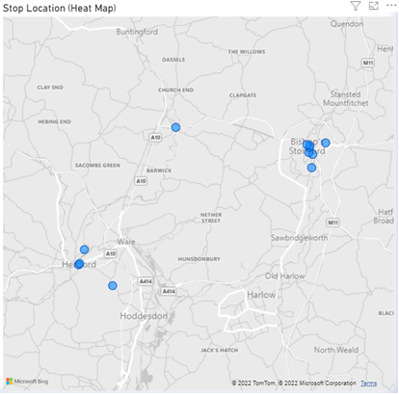

Repeat stop searches

Total Repeat Stop Searches 1
Total Individuals Subject to Repeat Stop Searches 1

Table shows stop search initiation reasons and break down of self defined ethnicity
Reason for Repeat Stop Search

Member of public led | 1
Intelligence Led | 1
Self-Defined Ethnicity - Repeat Stop Searches
B9 - Black Other | 1
B2 - African | 1
This was the same male who gave a different self-defined ethnicity on each stop

Repeat Stop Search  Individual | No. of stop searches | Intelligence submissions  Jan 2021 to Sept 2021
Subject 1 | 2 | 10 plus  Person managed by integrated offender management team

Officers with more than 2 stop searches on black males

(April to Sep 2021)

Officer A | 3
Officer B | 3

Same officers stop and searches on all Ethnicities

Total Searches
April to Sep
Officer A | 6
B2 - African
B9 - Black Other | 3
W1 - British | 2
W9 - White Other | 1
Officer B | 12
B2 - African | 1
B9 – Black Other | 2
A2 - Pakistani
A9 - Asian Other
NS - Not Stated | 1
W1 - British | 7
W9 - White Other | 1
Grand Total | 18

Due to the low numbers of searches in this time period this was also expanded on and reviewed across a 12-month period.

 | Total Stop Searches Jan-Dec 2021
Officer A | 14
A9 - Asian Other | 0
B9 - Black Other | 3
B2 - African | 0
M9 - Mixed Other | 1
NS - Not Stated | 1
O9 - Other Ethnic | 1
W1 – British | 6
W9 - White Other | 2
Blank | 0
Officer B | 19
A9 - Asian Other | 1
B2 – African | 1
B9 - Black Other | 0
M9 - Mixed Other | 0
NS - Not Stated | 1
O9 - Other Ethnic | 1
W1 – British | 11
W9 - White Other | 2
Blank | 2
Grand Total | 33

Outcomes – April to September 2021

Table shows outcomes of searches of black males (17stop and searches)

Outcome |  | Count | Percentage of Total
A no further action disposal |  | 13 | 76.5%
Arrest (because of items found) |  | 1 | 5.9%
Arrest (not related to the stop) |  | 3 | 17.6%
Caution (simple/conditional)
Community resolution
Cannabis Warning
Summons / charged by post
GRAND TOTAL |  | 17 | 100%
Table shows outcomes of searches on all males from other ethnicities

Outcome |  | Count | Percentage
A no further action disposal |  | 177 | 72%
Arrest (because of items found) |  | 23 | 9.3%
Arrest (not related to the stop) |  | 11 | 4.5%
Community resolution |  | 17 | 6.9%
Summons / charged by post |  | 13 | 5.3%
Caution (simple or conditional) |  | 2 | 0.8%
Cannabis Warning |  | 3 | 1.2%
GRAND TOTAL |  | 246 | 100.00%

As can be seen – no significant difference between the positive outcome rates for black males against all stop search.

Local context from East Herts CSP Senior Management Team

In East Herts the overall numbers of stop searches are quite low with an average of 45 per month. The highest figure for searches of black persons in any one month during the years data was 5 in July 2021.
In July 2021 in Hertford town centre there was an increase in activity of a group managed under Operation A. This group were involved in drug dealing and street Robberies. Several members began attending night time economy venues in Hertford contributing to significant disorder.
Of the 5 July searches 2 were attributed to this operation. This operation fed into the creation of a drug supply operation still ongoing under Operation B. In total of the 13 named black males searched between April and September 4 were linked to these operations. They were individuals briefed to local officers to disrupt their criminal activity.
The activity maps show more searches taking place in the urban areas, which is also reflected among the stops of white persons. We would expect this as these are the locations briefed as vulnerable locations for street robbery and drug dealing.
Only one individual was stopped more than once, he was the identified ringleader of the afore mentioned Operation A. He is an identified habitual knife carrier and managed as such by Herts police.
Two officers feature as having more than 2 stops on black males. Both officers were attached to the proactive Op Scorpion team where they would be focusing on stop search more than other teams. Both searched persons across ethnicities. It cannot be concluded that this is discriminatory behaviour.
24% of the black males searched do not live in Herts. When considered against such low figures of 17 searches of black males over 6 months this has a substantial impact on the disproportionality figures. A further 41% did not provide an address providing further confusion to the data.

Comment from the OPCC Stop and Search Independent Scrutiny Panel on review of this document:
The panel very much welcome this second deep dive.

As noted within the document the sample size is small. As the overall number of Stop & Searches in East Herts is low, any increase can stick out. The report explains some of these increases with justification of specific police operations / intelligence.

The report highlights the number of stops which were on those who do not live in East Herts (or who wouldn’t provide an address). East Herts is served by two train lines and supports the point that there is a flow of individuals from out of the area making regular visits along this corridor. Every stop & search will also require grounds and justification regardless of whether that individual lives locally or not.

The report is fair and overall there seems to be no discrimination.

Conclusions

Throughout this review no overt discrimination was evident

The vast majority of the stops were linked to intelligence, proactive operations (where officers were briefed and directed with intelligence) or calls from members of the public.

The one subject who was searched more that once has a number of intelligence submissions and the main individual identified as part of an operation proactively targeting drug dealing and robberies within the CSP.

It must be noted that the disproportionality ratio is calculated in regards to resident population – 41% of the stops had no address which makes it impossible to understand the exact disproportionality ratio.

Recommendations
Data quality – officers need refreshed training and guidance to understand the important of gaining self-defined ethnicity and addresses as much as possible. Supervisory mandatory dip sampling of body worn video can ensure compliance in trying to achieve this.

