Primary Operator: | PC 5924 KILLEN |  | Secondary Operator: | PC 490 BURTON
Deployment Name: | Slam Dunk Festival |  | Deployment Date: | 23/05/2026 | Start Time | 1135hrs
 |  |  |  |  | End Time | 1600hrs
Location: | Hatfield Great North RD |  | W3W Location: | Gets.assure.spoil
Weather: | Sunny, Dry |  | Threshold Used: | 0.64
Watchlist Composition
List | Type | In Use | Enrolled Images |  |  | Notes (inc image specific threshold)
List | Type | In Use | Total (all) | 13 & under | 14 - 17 | Notes (inc image specific threshold)
Red | CT | ☐
Yellow | Warrants | ☐
Green | Court Imposed Conditions | ☐
Purple | High Level Suspects | ☒ | 126
Grey | Lower-Level Suspects | ☒ | 413
R | Mispers | ☐
Gold | Event Specific | ☐
Amber | SHPO¹ | ☒ | 556
Aqua | Other Defined by AO | ☐
Blue | Police / Friendly / Test List | ☒ | 4
Deployment total: |  |  | 1099
¹Sexual Harm Prevention Orders
Alert Summary
 | Red | Yellow | Green | Purple |  | Grey | Magenta |  | Gold | Orange | Aqua | Blue
False unconfirmed
False confirmed
True unconfirmed
True confirmed
Total:
Info: unconfirmed = no engagement or interaction  confirmed = engaged or spoken to |  |  |  |  | Total Faces Seen:

Additional Deployment Location (if required)
Location: |  |  | Deployment Date: |  | Start Time
 |  |  |  |  | End Time
Weather: |  |  | W3W Location:

Operator Deployment Notes
1135hrs Camera up
1230hrs Front camera fogged up positioned towards the sun
1238hrs Front camera up
1300hrs Removed James CONNERS from watchlist
1600hrs Cameras down

Alert Information
 | Time | Watchlist | True Alert | False Alert | Confirmed | Age | Sex | ODE | Outcome (inc URN)
1 |  |  | ☐ | ☐ | ☐
2 |  |  | ☐ | ☐ | ☐
3 |  |  | ☐ | ☐ | ☐
4 |  |  | ☐ | ☐ | ☐
5 |  |  | ☐ | ☐ | ☐
6 |  |  | ☐ | ☐ | ☐
7 |  |  | ☐ | ☐ | ☐
8 |  |  | ☐ | ☐ | ☐
9 |  |  | ☐ | ☐ | ☐
10 |  |  | ☐ | ☐ | ☐
11 |  |  | ☐ | ☐ | ☐
12 |  |  | ☐ | ☐ | ☐
13 |  |  | ☐ | ☐ | ☐
14 |  |  | ☐ | ☐ | ☐
15 |  |  | ☐ | ☐ | ☐

Officer Defined Ethnicity |  | 4 | Asian
1 | White North European | 5 | Chinese, Japanese, SE Asian
2 | White South European | 6 | Arabic or North African
3 | Black | 7 | Unknown

APP Compliance – Privacy Notices
Use the space below to insert an image of the signage along with the What3Words location.

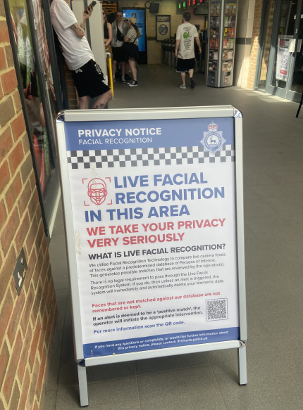 |  | 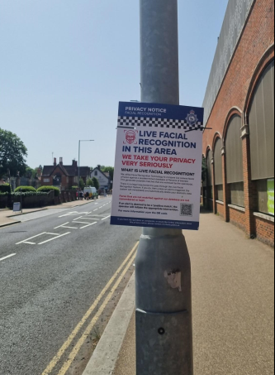 |  | 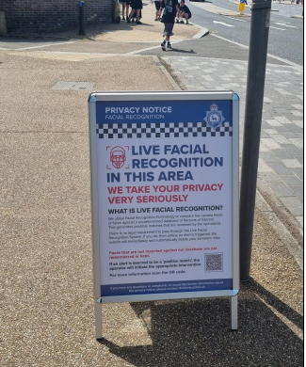
/// | Scuba.light.heat | /// | Gladiators.visits.hails | /// | Monday.swim.ports
/// |  | /// |  | ///
/// |  | /// |  | ///

