Primary Operator: | PC 27 McCathie |  | Secondary Operator: | PS 6591 COATES
Deployment Name: | Slam Dunk Festival |  | Deployment Date: | 23/05/2026 | Start Time | 11:45
 |  |  |  |  | End Time | 16:00
Location: | French Horn Lane Hertford |  | W3W Location: | Flank nail clash
Weather: | Bright and sunny |  | Threshold Used: | 0.64
Watchlist Composition
List | Type | In Use | Enrolled Images |  |  | Notes (inc image specific threshold)
List | Type | In Use | Total (all) | 13 & under | 14 - 17 | Notes (inc image specific threshold)
Red | CT | ☐
Amber | Warrants | ☐ | 559 |  | 1 | 15 y/o warrant number 41/10333/26
Green | Court Imposed Conditions | ☐
Purple | High Level Suspects | ☐ | 128 |  | 2 | 15 wanted for burglary 41/102048/23  15 wanted for assault PC 41/43056/26
Grey | Lower-Level Suspects | ☐ | 419 |  | 4 | 15 wanted for 41/86734/25  16 wanted for 41/B2/14844/25  16 wanted for robbery 41/117526/25  17 wanted for assault 41/95273/24
Magenta | Mispers | ☐
Gold | Event Specific | ☐
Orange | SHPO¹ | ☐
Aqua | Other Defined by AO | ☐
Blue | Police / Friendly / Test List | ☐ | 4
Deployment total: |  |  | 1110 | 0 | 7
¹Sexual Harm Prevention Orders
Alert Summary
 | Red | Amber | Green | Purple |  | Grey | Magenta |  | Gold | Orange | Aqua | Blue
False unconfirmed
False confirmed
True unconfirmed
True confirmed
Total:
Info: unconfirmed = no engagement or interaction  confirmed = engaged or spoken to |  |  |  |  | Total Faces Seen: |  |  | 6163

Additional Deployment Location (if required)
Location: |  |  | Deployment Date: |  | Start Time
 |  |  |  |  | End Time
Weather: |  |  | W3W Location:

Operator Deployment Notes
10:45 – Signs out, cameras positioned. Weather bright and sunny. Boxing faces well both cameras no fog on either lens.
12:15 – Neoface system fault. System processes stopped and unable to restart. Complete reboot multiple times. Liaised with Dom South Wales Police.
13:10 – System back up and running. Boxing well.
16:00 – Cameras down.

Alert Information
 | Time | Watchlist | True Alert | False Alert | Confirmed | Age | Sex | ODE | Outcome (inc URN)
1 |  |  | ☐ | ☐ | ☐
2 |  |  | ☐ | ☐ | ☐
3 |  |  | ☐ | ☐ | ☐
4 |  |  | ☐ | ☐ | ☐
5 |  |  | ☐ | ☐ | ☐
6 |  |  | ☐ | ☐ | ☐
7 |  |  | ☐ | ☐ | ☐
8 |  |  | ☐ | ☐ | ☐
9 |  |  | ☐ | ☐ | ☐
10 |  |  | ☐ | ☐ | ☐
11 |  |  | ☐ | ☐ | ☐
12 |  |  | ☐ | ☐ | ☐
13 |  |  | ☐ | ☐ | ☐
14 |  |  | ☐ | ☐ | ☐
15 |  |  | ☐ | ☐ | ☐

Officer Defined Ethnicity |  | 4 | Asian
1 | White North European | 5 | Chinese, Japanese, SE Asian
2 | White South European | 6 | Arabic or North African
3 | Black | 7 | Unknown

APP Compliance – Privacy Notices
Use the space below to insert an image of the signage along with the What3Words location.

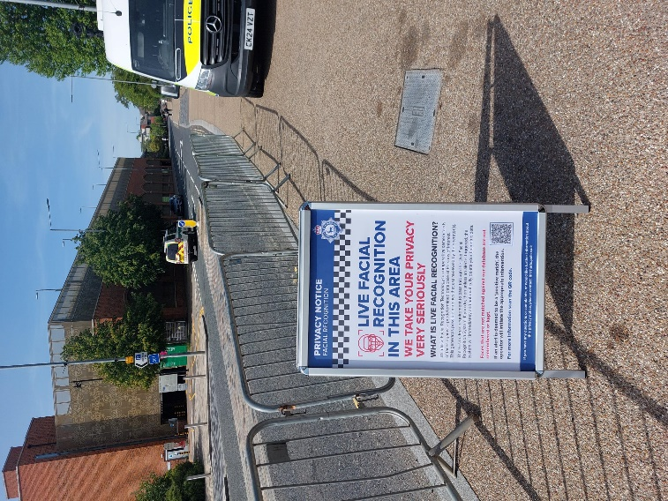 |  | 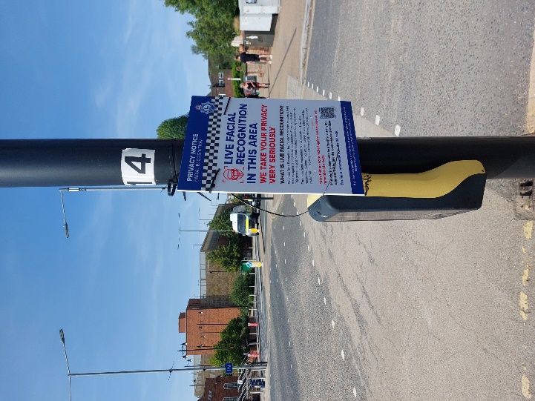 |  | 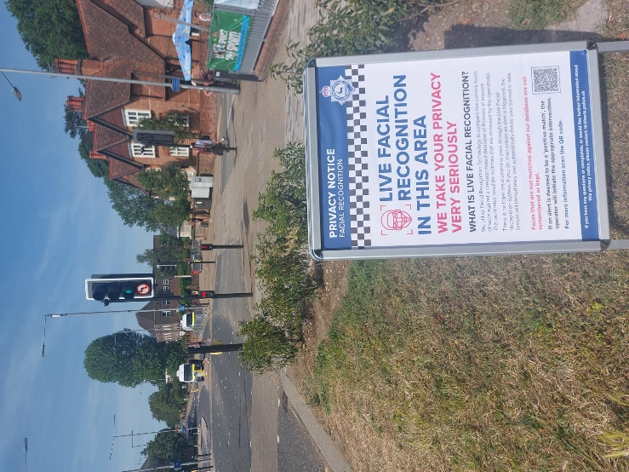
/// | Pasta shaped bike | /// | Pint burst doing | /// | Player neck trim
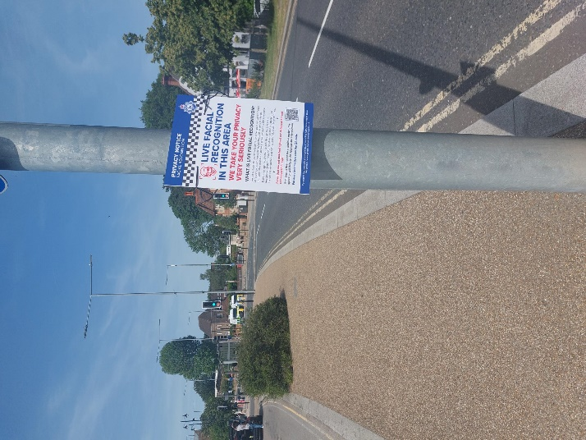

/// | Treat most tools | /// |  | ///
/// |  | /// |  | ///

